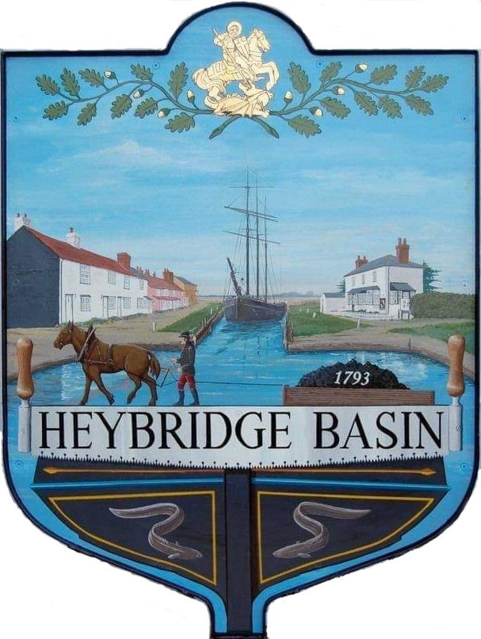

HEYBRIDGE BASIN PARISH COUNCIL

Minutes of the Full Council meeting of Heybridge Basin Parish Council held on Tuesday 14th January 2025 at 06:30pm, at St George’s Community Room.

PRESENT

In the Chair: M. Hodges (Chair) Absent: 0

Councillors: R. Bryson (Vice Chair) Apologies: 1
J. Sjollema
C. Edmond District Cllrs: 1
M. Hobden
G. Howatt Public: 1

Officers: G. Lake – Clerk

It was noted that this meeting was being recorded by the Clerk.

24/149 Chair’s Welcome.
The Chair welcomed everyone to the meeting and was pleased to report that the salt bags had been delivered by Cllr Swann, and the bird boxes had been constructed and delivered.

24/150 To note apologies for absence.
Cllr Swann

24/151 To receive Declarations of Interest in accordance with the Council’s Code of Conduct and with section 106 of the Local Government Finance Act 1992.
Cllr Edmond – Non-Pecuniary – Essex Waterways; Cllr Howat – Non-Pecuniary – Heybridge Basin Conservation Society and Cllr Hobden – Non-Pecuniary – Basin Oars, Rivercare Group and Heybridge Basin Sailing Association

24/152 To sign as a correct record the minutes of the full council meeting held on 17th December 2024.
The Minutes as previously circulated were agreed and signed as a correct record.

24/153 To receive a report from:
- District Councillors – Cllr Spenceley gave a verbal report regarding the recently approved National Planning Policy Framework as well as the news surrounding the devolution and local government reorganisation.
- County Councillor – No report was received from Cllr Durham; however, it was reported that the gateways have been rescheduled to 18th February 2025.

24/154 Finance.
- To approve
- Payment requests for December 2024/January 2025 were approved.
- Receipts for December 2024/January 2025 were approved.

24/155 Public Forum
No members of public wished to speak.
24/156 Planning
- To consider any planning applications received after the publication of the agenda and to agree the action to be taken.
There were no planning applications.

24/157 Daisy Meadow Car Park (DMCP)
  - To discuss the design and costs for the car park garden at the old toilet block and agree any action to be taken.
A report outlining the phase one landscape plan and costs had previously been circulated. It was resolved to order the proposed materials and hire HRS Marine Services to carry out the work, totalling £3,700.00.
It was noted that there is a water supply underneath the concrete, and accessing this water would require digging it up and rerouting it. An estimated cost of £1,720 was advised. It was resolved to get a quote for a standpipe.
  - To consider a proposal for the installation of a memorial bench for former Councillor, Keith Lawson and agree any action to be taken.
The Council resolved to place a memorial bench in honour of former Cllr Lawson in the new car park garden and would consider contributing towards the cost of the bench once a design had been chosen.

24/158 VE Day 2025
  - To receive an update from the Working Group and agree any action to be taken.
The Clerk previously circulated a report outlining tasks to be completed and addressing questions related to the event. Tasks were delegated to members of the Council and the Clerk. The Clerk will update the notes and recirculate them. It was resolved to refill a gas cylinder at a cost of £104.00 plus VAT and order a 36” VE Day flag at a cost of £20.60

Cllr Howat left the meeting.

24/159 Goal Posts
  - To discuss the goal posts and agree any action to be taken.
The Clerk advised that the basketball hoop requirement form had been submitted, and the Council was awaiting a response from Tesco Community Grants regarding the application. It was resolved that the Council would cancel the grant request and proceed with purchasing the goal posts at a cost of £1,306 inclusive of VAT and delivery. Additionally, quotes for installation would be sought.

24/160 Village Sign
- To discuss the condition of the village sign wooden post and agree any action to be taken.
It was reported that the wooden post of the village sign was rotting. Discussions took place regarding the use of a metal base to insert the post. Cllr Bryson was tasked with seeking quotes for the work.

24/161 Correspondence
- To note correspondence received and agree any actions to be taken.
Correspondence was noted and responses were agreed.

24/162 Newsletter
  - To consider items to be included in the next Parish Council Newsletter and delegate articles to Councillors.
- Memorial post, Precept, and Defib Training – Clerk
- No Mow May and Parking Regulations – Cllr Hodges
- Basketball Hoop/Goal Posts – Cllr Bryson
- Raised bed in DMCP – Cllr Hobden
- VE Day, Cake Competition and Beacon Lighter – Collective

There being no further business the meeting closed at 07:47pm
Provisional Date of the next Council Meeting Tuesday 25th February 2025

Clerk Contact details: clerk@heybridgebasinpc.org.uk
Website: www.heybridgebasin-pc.gov.uk

